The Land Code is the basic enabling Land Law of Fort William First Nation. The Land Code sets out the principles, rules and administrative structures for our lands and resources within the reserve boundary of Fort William First Nation. If approved by the Members, we will regain control of our own land management decisions much like our ancestors enjoyed.
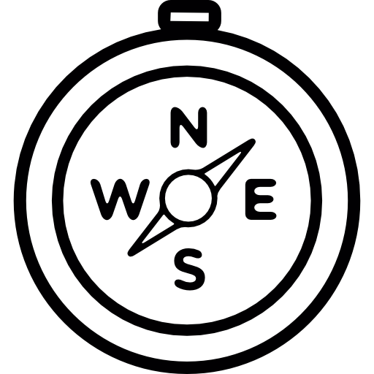
`
(disputes, processes, etc.)
Part 8: Dispute Resolution
Part 6: Land and Natural Resources Administration
(land staff and Committee)
Part 4: Protection of Land
(purchase, expropriation)
Tina Morriseau, Lands Administrator
Phone: 807.623.9543
Email: tinamorriseau@fwfn.com
For more information on our Land Code, please contact:
Fort Wililam First Nation
Land Code
Part 9: Other Matters
(offences, revisions, commencement)
Part 2: First Nation Legislation
(procedure, enforcement, etc.)
Part 3: Community Meetings and Approvals
Part 5: Accountability
(financial management and reporting)
Part 7: Interests and Licences in Land
(CPs, leases, residency, mortgages, etc.)
Part 1: Preliminary Matters
(definitions, purpose, etc.)
LAND CODE SUMMARY
Fort William First Nation has the right to govern ourselves in relation to matters that are integral to our culture, identity, traditions, language, and with respect to our special relationship to the reserve lands and resources.
Part 1: Preliminary Matters
Terms used in the Land Code are described here, an explanation of where the authority to govern comes from, what the purpose of the Land Code is, and what lands the Land Code applies to (the reserve land description).
Part 2: First Nation Legislation
Fort William First Nation law making powers are outlined here, and how new land laws will be made. We will have the jurisdiction to enforce compliance with land laws, rules and obligations.
Part 3: Community Meetings and Approvals
Certain land laws and other important land matters must be approved by the community before they can take effect. Every eligible voter, whether living on or off reserve, can participate in community approval processes and ratification votes to discuss and decide on these matters.
Part 4: Protection of Land
The right of Fort William First Nation to expropriate can only be exercised after a good faith effort to acquire, by mutual agreement, the interest or licence. The Land Code and Framework Agreement provide clear and transparent rules for expropriation, notification, compensation, and public reporting and requires Member approval. The Land Code protects against loss of reserve land through surrender for sale and expropriation. However, Fort William First Nation may decide that it is advantageous to exchange some of its reserve land for other lands. An exchange of land can only occur with the consent of the Members.
Part 5: Accountability
Council is accountable to Members for the management of moneys and land under the Land Code. An annual report will be prepared and published for the Members. Any person may have reasonable access to the register of land laws, the auditor’s report and the annual report on reserve land and natural resources. The existing rules on conflict of interest will continue to apply to Council, employees, members of the Dispute Resolution Panel and any Lands Committee or board.
Part 6: Land and Natural Resource Administration
Council may delegate administrative authority to staff to carry out functions necessary for day-to-day administrative operations of Fort William First Nation lands and natural resources. A Lands Committee will be established to deal with administration and law development and advising Council on land matters.
Part 7: Interests and Licences in Land
This section defines how revenue monies from lands will be handled (from fees, leases, etc.), how the registration of land interests (leases, permits, licences) will be conducted and how they are registered. Existing Interests and Licences that existed before the Land Code will continue as normal (Member and 3rd party interests). New land interests and licences, and transfers will be done by Fort William First Nation under Land Code. This section also defines the limits on mortgages and seizures, transfers upon death, and the principles for spousal property law (to be made into a Matrimonial Real Property law).
Part 8: Dispute Resolution
The dispute resolution process ensures all persons entitled to possess, reside on, use, or occupy Fort William First Nation land do so harmoniously with due respect to the rights of others. These rules enable the parties to a dispute to achieve a just, speedy and inexpensive determination of a matter in dispute.
Part 9: Other Matters
The summary conviction provisions of the Criminal Code apply to offences under the Land Code or land law enacted under the Land Code unless some other procedure is provided for by a land law. This Land Code shall take effect if the community approves this Land Code and the Individual Agreement with Canada. Nothing is final without Member approval.

